1. How does the cartoonist illustrate political corruption?
2. What does the “Prohibition Agent” refer to?
3. The 1920s were a time of economic growth and prosperity. How does this cartoon suggest the underlying instability of the so-called “Roaring Twenties”?

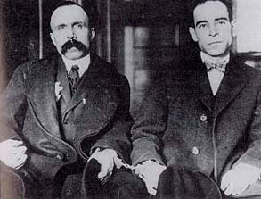

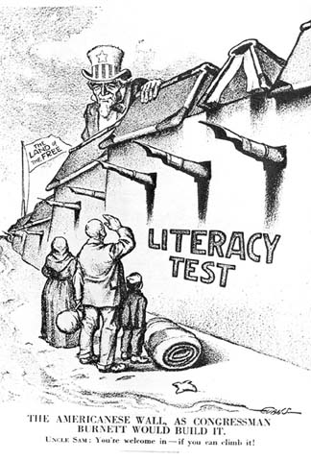

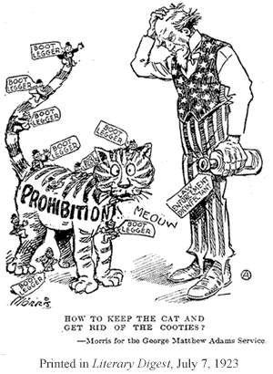

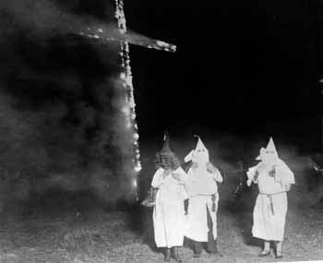

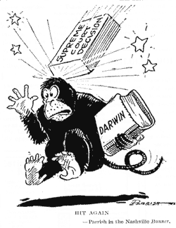

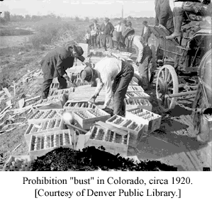

BIgotry

